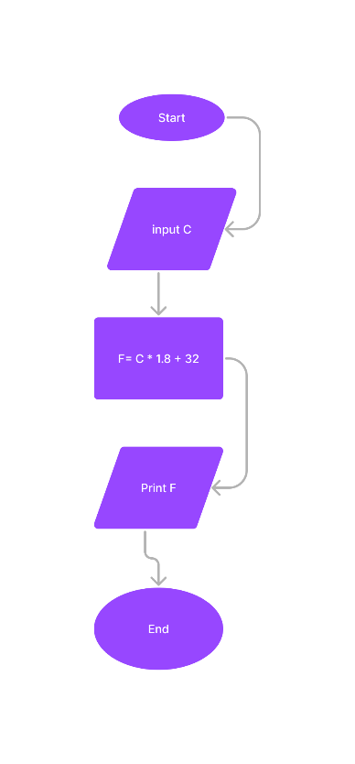Begin

Input C

    F = (9\*C)/5 + 32

Print F

End